Table of Contents

Welcome Letter 4
Table of Contents
Directions/Transportation
Location Maps 5-7
Event Services/Support Services
Audio-Visual Services 8
Decorator Services ……………………….8
Event Manager 8
Event Services Estimate 9
Parking 9
Security 10
Utilities 11
Facility Event Services
Box Office 12
Coat/Baggage Check 12
Computer Connections 12
Concessions ..12
Equipment Inventory and Rental 12
Event Staffing 12
First Aid 12
Food and Beverage Services 12

Hampton Convention & Visitor
Bureau Services 12
Information Desk/Guest Services 13
Information Kiosks 13
Paging System 13
Registration Space 13

Show Manager’s Office 13
Telephone Service 13
Facility Operations Guidelines
Abandoned Equipment 14
Access 14
Adhesive Backed Decals 14
Air Conditioning 14
Alcohol 15
Amendments 15
Americans with Disabilities Act 15
Animals 15
Business Licenses/Health
Permits/Taxes 15

Carpet Tape 15
Cleaning and Custodial Service 15
Conduct 16
Cooking Regulations 16
Crate Storage 16
Damages 16
Decorations, Banners and Posters 16
Elevators and Escalators 16
Event Plan 16
Fire Code Regulations 17
Floor Marking 18
Floor Plans 18
Food & Beverage Sampling 19

Freight Deliveries/Receiving ..19
Freight Elevators 19
Furniture and Equipment 19
Gratuities 20
Inventory 20
Inspections 20
Insurance 20
Lasers 20
Motorized Vehicles 20
Move In/Move Out 21
Novelty and Concessionaries 21
O.S.H.A. Regulations 21
Overhead Doors 21
Portable Walls 21
Public & Common Areas 21
Refunds 21
Returned Check Policy………………….21
Rigging 21
Room Capacities 22
Safety 22
Settlement 22
Signage 22
Smoking Policy 22
Solicitations 22
Sound/Lighting 22
Taxes 23
Truck Marshalling 23
Waste Materials 23

Appendix
Credit Card Authorization Form A
Event Planning Checklist B
Insurance C
Sample Insurance Certificate D
Hampton Health Department E

Dear Valued Client:
Welcome

Welcome to the Hampton Roads Convention Center, an SMG-managed facility! We are honored you have chosen us as your host and look forward to assisting you with your event. Our goal is to provide you with excellent service to ensure your production is a memorable and successful occasion that exceeds your expectations. We wish to establish with you a relationship of trust and confidence that prompts you to return many times to the Hampton Roads Convention Center for your convention and special event needs.
Communication between our organizations will be essential as we coordinate the numerous details involving your meeting, conference or social affair. This Hampton Roads Convention Center Event Planning Guide will facilitate the planning process by providing event service, operations and facility-request procedures and information. The guide will serve as a valuable handbook and complement to the personal interaction you will have with your event manager throughout the planning process.
The Hampton Roads Convention Center was designed to be both aesthetically pleasing and functional, to impress attendees while serving the needs of the event planner. The center’s 344,000 total square feet of versatile convention and exhibit space ensures great flexibility for you and your participants. The ballroom presents banquet seating for more than 2,000 and our spacious 102,000-square-foot exhibit hall divides into three sections. An intimate conference center within the facility provides privately accessed, semi-secure meeting space, and our terrace overlooking our campus of glistening streams and fountains is a spectacular spot for twilight receptions.
A sparkling 295-suite, John Q. Hammons Embassy Suites Hotel connects to the Hampton Roads Convention Center by covered walkway. There are 2,500 hotel rooms within walking distance and nearly 3,000 rooms within a few minutes’ drive of the Hampton Roads Convention Center. The hotel offers a restaurant, lounge and decadent day spa, among other amenities. Completing the campus, the Hampton Coliseum offers an additional 84,000 total square feet to accommodate up to 11,000 people in an arena setting.
Our neighboring cities of Williamsburg, Norfolk, Newport News and Virginia Beach complement Hampton’s offering of exciting and entertaining activities. More than 100 attractions are located within a thirty-minute drive of the convention center. The Hampton Roads Convention Center presents flexibility, versatility and hospitality in the center of it all.
Together, we will produce an exceptional event. We hope it will be the first of many.

Sincerely,

Eric P. Nealy

Eric P. Nealy
General Manager
Directions/Transportation/Location Maps
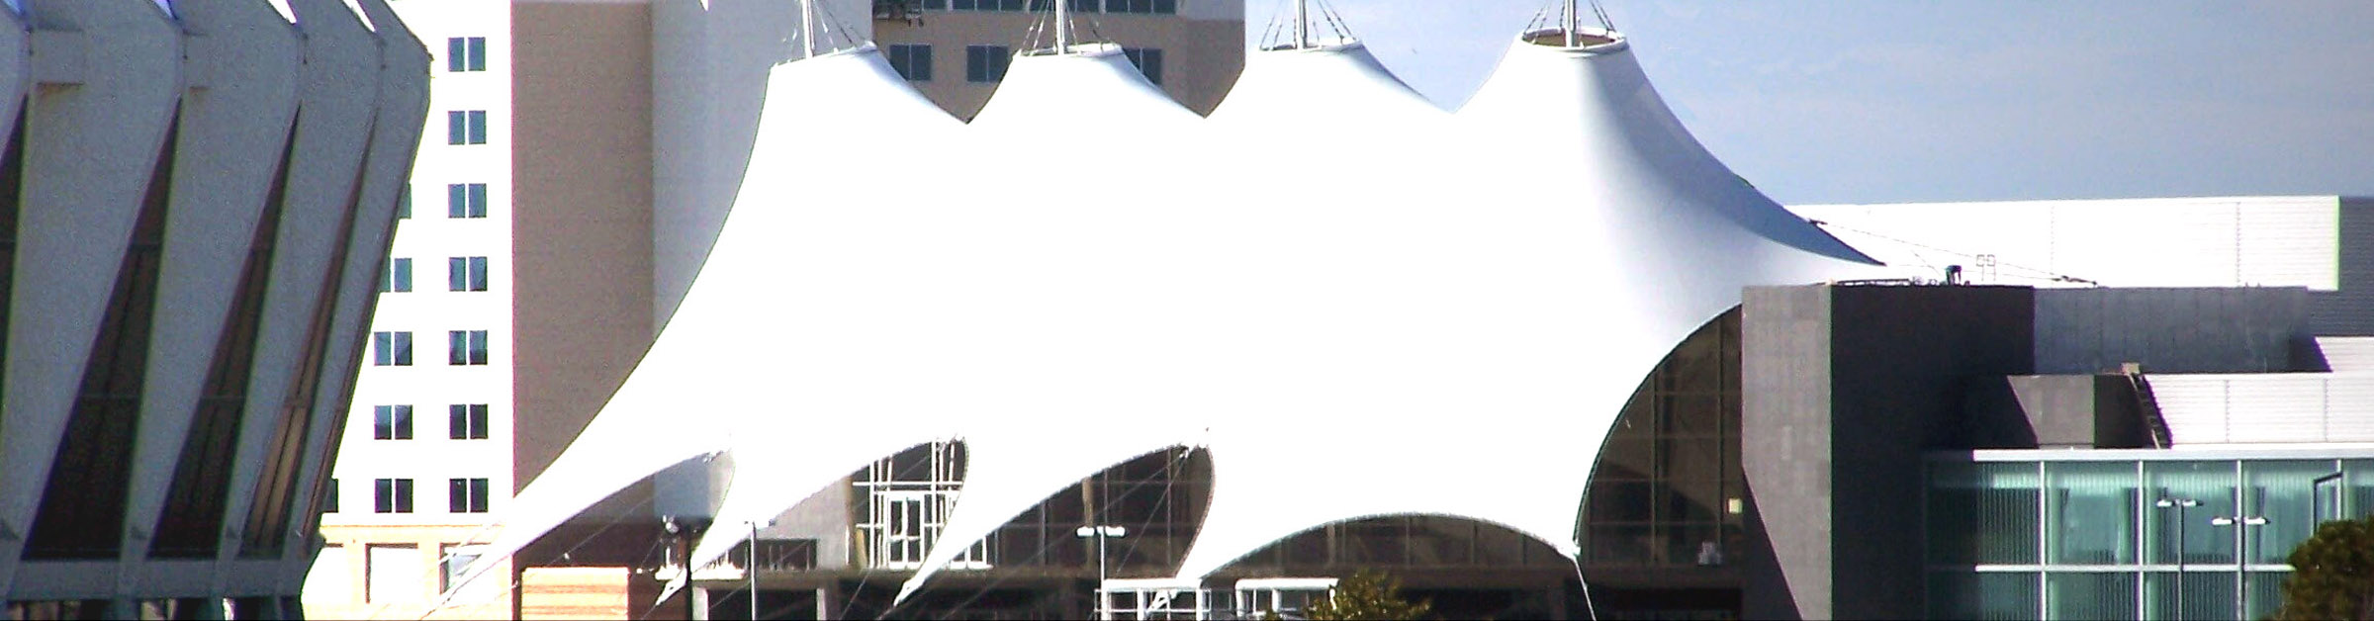

- Directions to the Hampton Roads Convention Center

From Washington, DC
Proceed on I-95 to I-295 to I-64 to Norfolk/VA Beach. Before reaching the Hampton Roads Bridge Tunnel, take Exit 263 (W. Mercury Blvd/Hampton Coliseum). Make a left at the bottom of the ramp onto W. Mercury Boulevard and make a right onto Coliseum Drive. Follow Coliseum Drive through the intersection at Pine Chapel Road and the Hampton Roads Convention Center will be on your left.
From Eastern Shore/
Chesapeake Bay Bridge Tunnel
Rt. 13 South will turn into Northampton Boulevard. Continue straight ahead until you reach I-64 W (Hampton/ Richmond) junction. Stay on I-64 W through the Hampton Roads Bridge Tunnel and take Exit 263-B (Hampton Coliseum/W. Mercury Boulevard). Curves around and the Clarion will be on your right, take the first right onto Coliseum Drive. Follow Coliseum Drive through the intersection at Pine Chapel Road and the Hampton Roads Convention Center will be on your left.

From I-95/Rocky Mount,
North Carolina:
Take I-95 to Emporia, take Route 58 and follow that until your reach I-664 (Newport News/Hampton) junction. Follow that through the Monitor-Merrimac Bridge Tunnel and take Exit 2 (PowerPlant Parkway/Powhatan Parkway). Make a left at the top of the exit ramp onto PowerPlant Parkway. Follow that and make a right onto Pine Chapel at the Bass Pro Shops Outdoor World. Once on Pine Chapel Road, make a right onto Coliseum Drive and the Hampton Roads Convention Center will be on your left.

From I-85 Atlanta
I-85 North to South Hill, take Route 58 and follow that until your reach I-664 (Newport News/Hampton) junction. Follow that through the Monitor-Merrimac Bridge Tunnel and take Exit 2 (PowerPlant Parkway/Powhatan Parkway). Make a left at the top of the exit ramp onto PowerPlant Parkway. Follow that and make a right onto Pine Chapel at the Bass Pro Shops Outdoor World. Once on Pine Chapel Road, make a right onto Coliseum Drive and the Hampton Roads Convention Center will be on your left.

- Transportation
Airports
Newport News/ Williamsburg International Airport: 757-877-0924
I-64 and Jefferson Ave Exit 255B
Carriers: Delta and American Airlines

Norfolk International Airport:
757-857-3351
I-64 and Norview Ave, Exit 279
Carriers: Allegiant, American, Delta, Southwest, and United
Amtrak 1-800-872-7245
Buses
Hampton Roads
Hampton Roads Transit 757-222-6100

Taxi
Yellow Cab of Hampton 757-853-1896
Orange Cab Co. 757-369-8977
North End Taxi 757-244-4000
Shuttle/private car/limo
James Limousine 757-273-1540
VA Executive Sedan & Limousine Service 757-693-4425

- Maps & Geographic Location
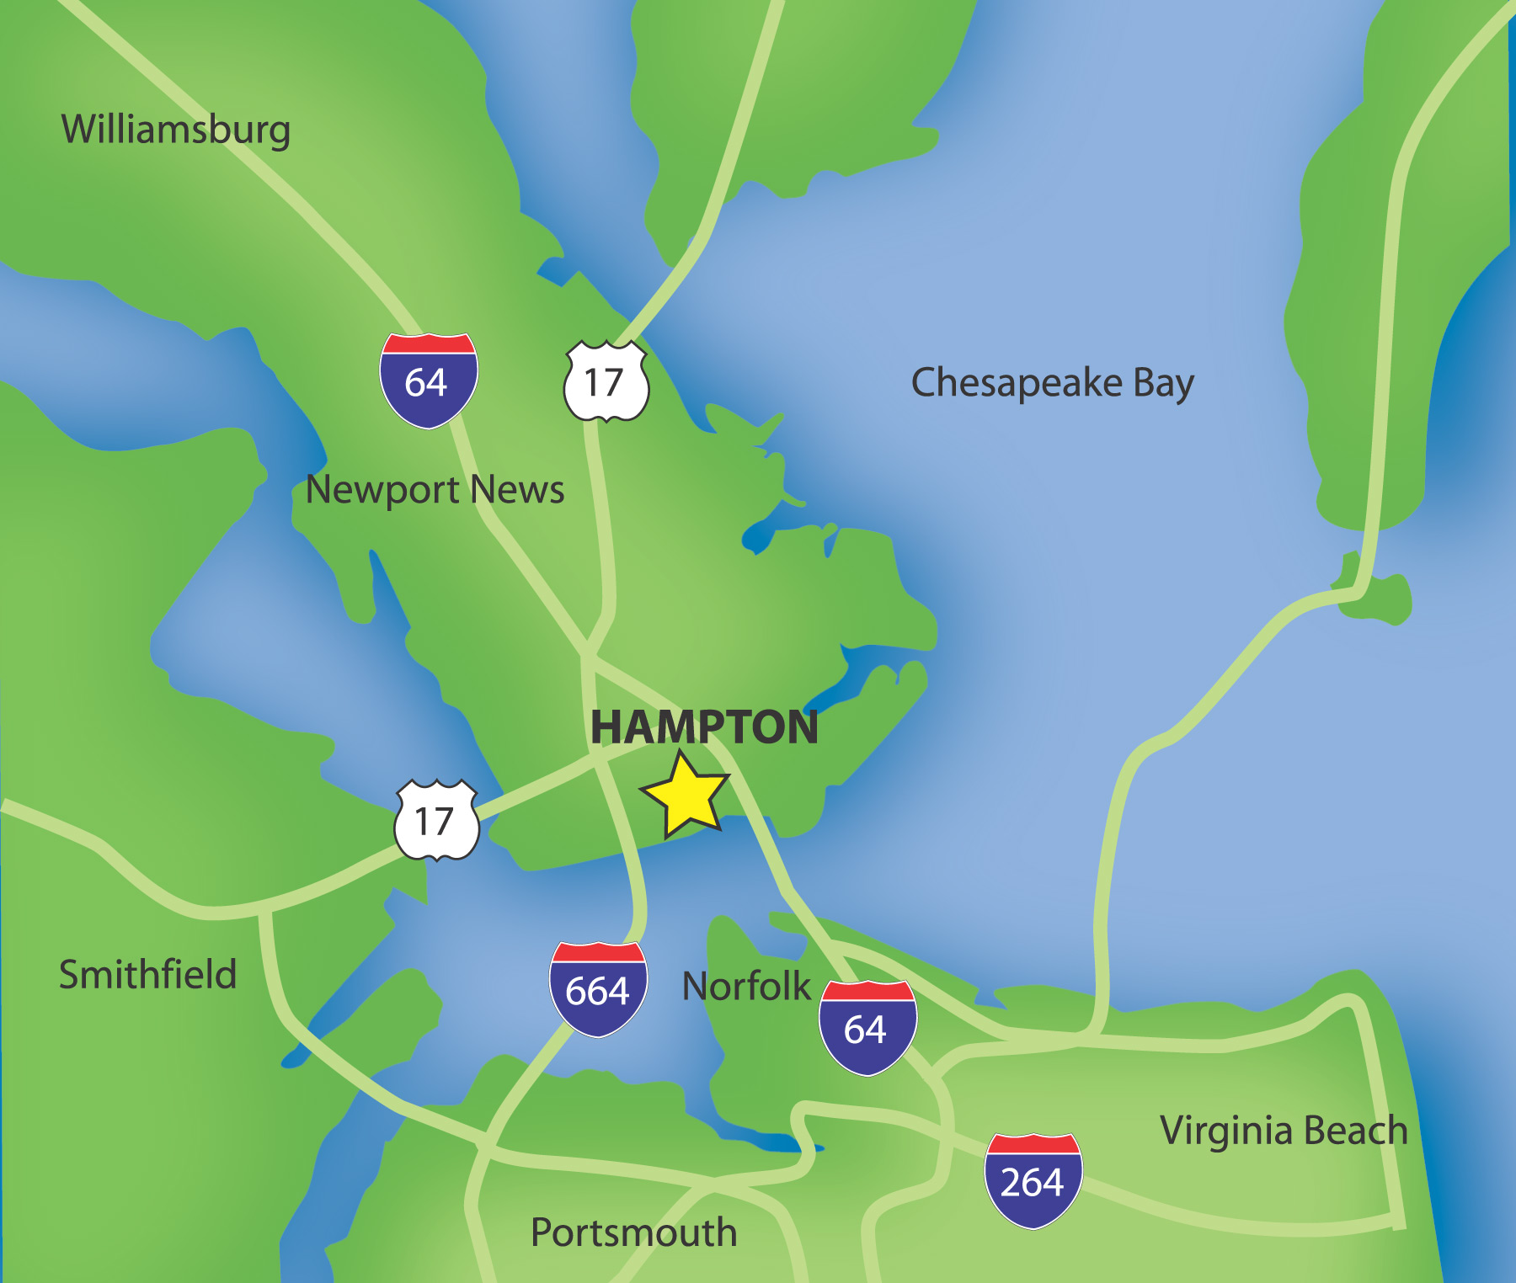
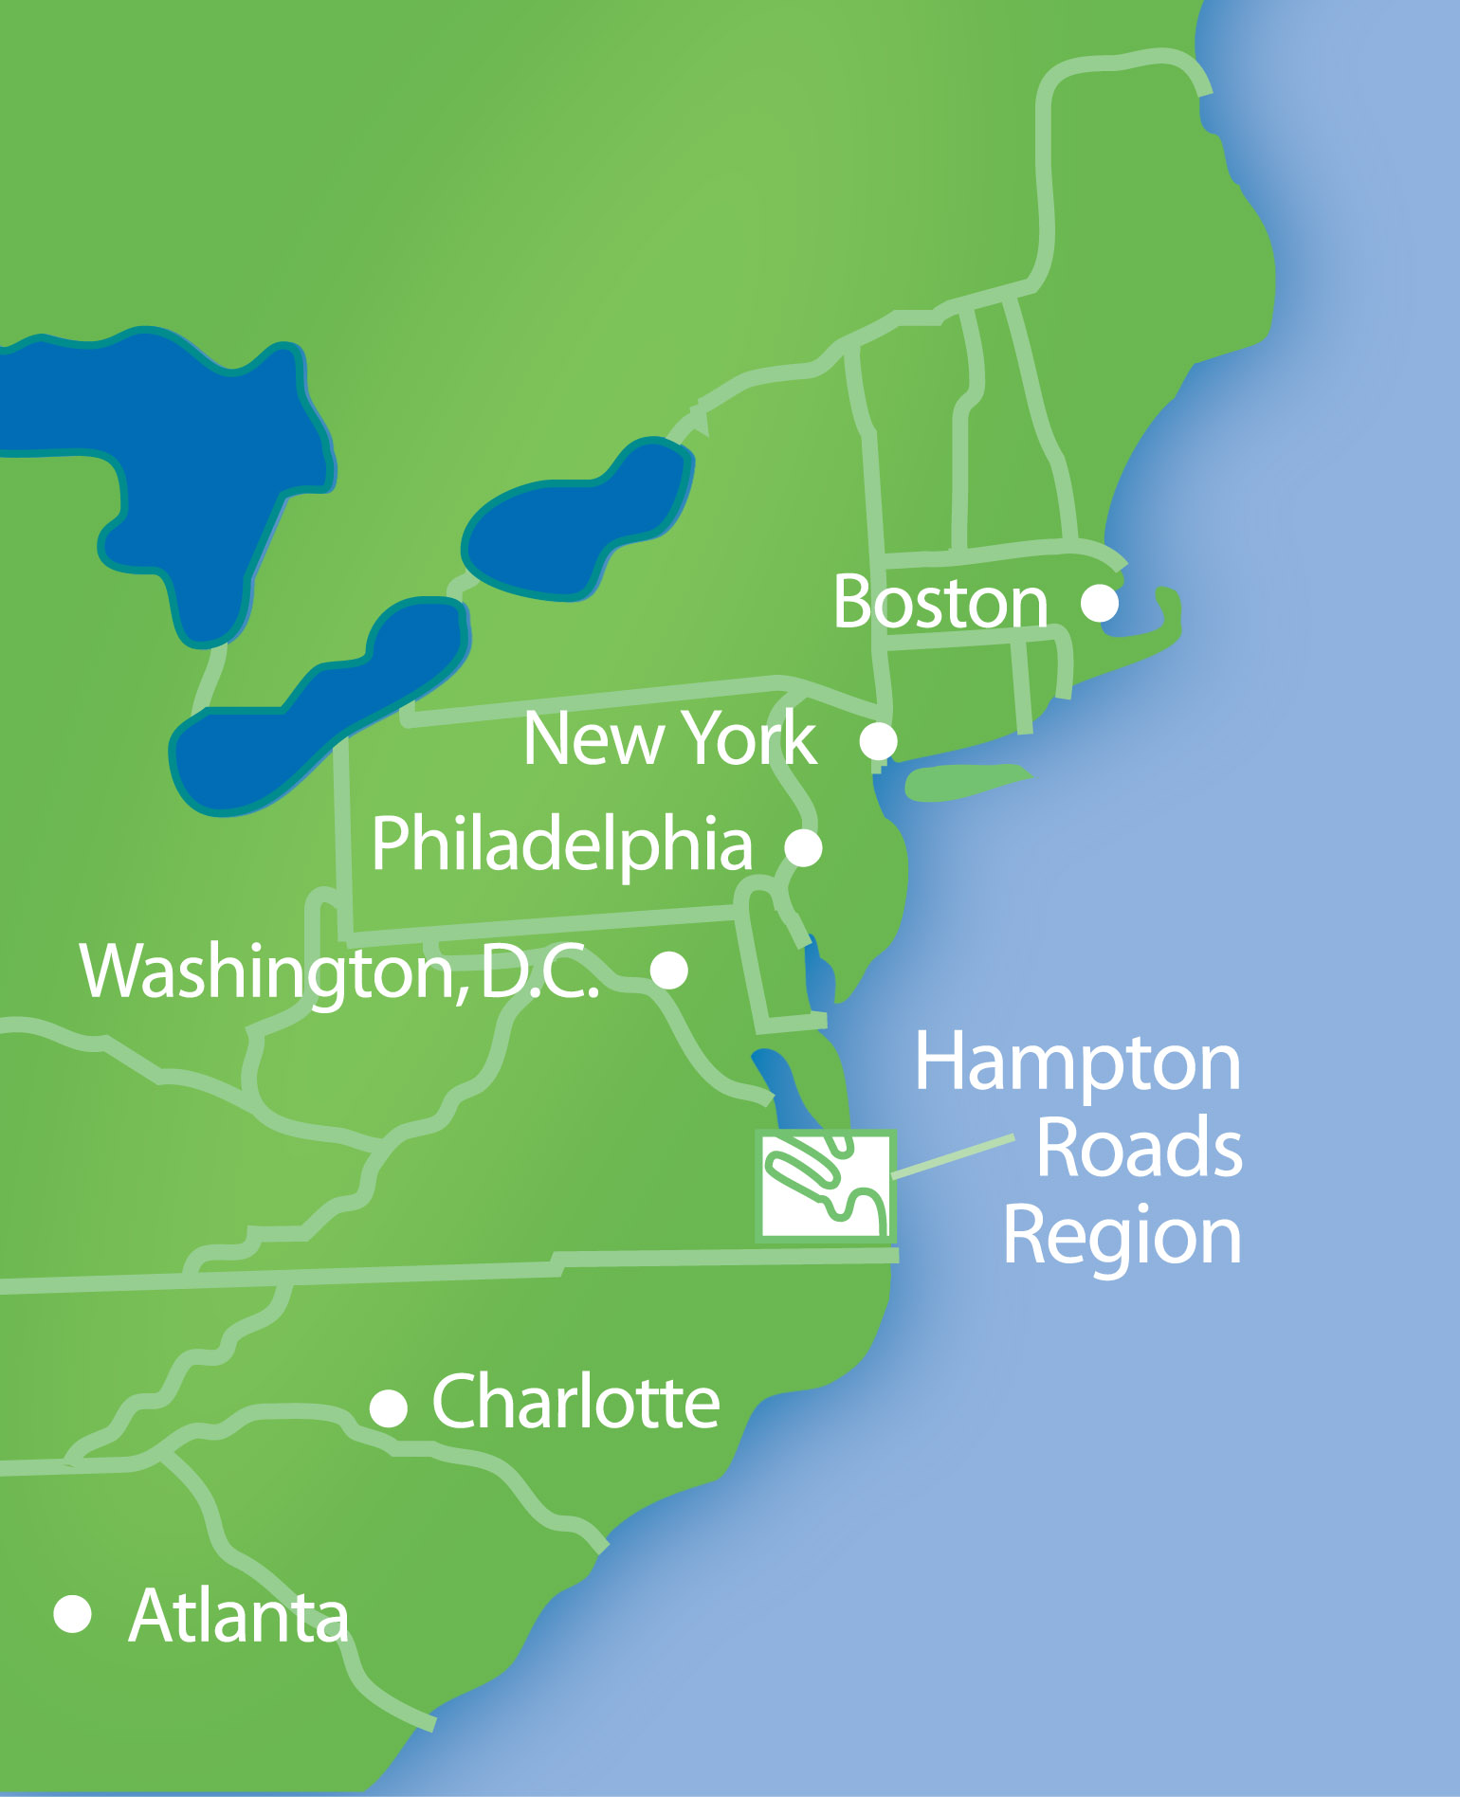

The Hampton Roads Convention Center (HRCC) is located in the geographic heart of the Hampton Roads metropolitan area. Hampton is located in close proximity to Williamsburg, Norfolk and Virginia Beach. Easily traversable, Interstates 64 and 664 meet at the Hampton Roads Convention Center’s doorstep, providing delegates with easy access to the more than 100 attractions within a thirty-minute drive of the facility.

Getting here is a breeze! Two-thirds of the East Coast’s population is within a day’s drive or less of the Hampton Roads Convention Center. Newport News/Williamsburg and Norfolk International airports serve Hampton, and Amtrak is stationed only minutes away, affording multiple travel options.
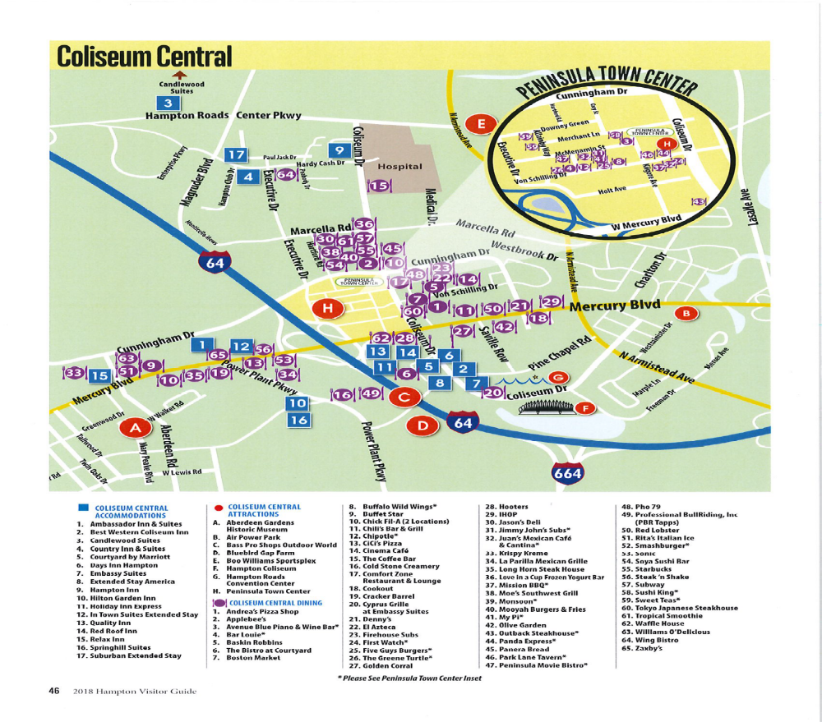

Event Services/Support Services
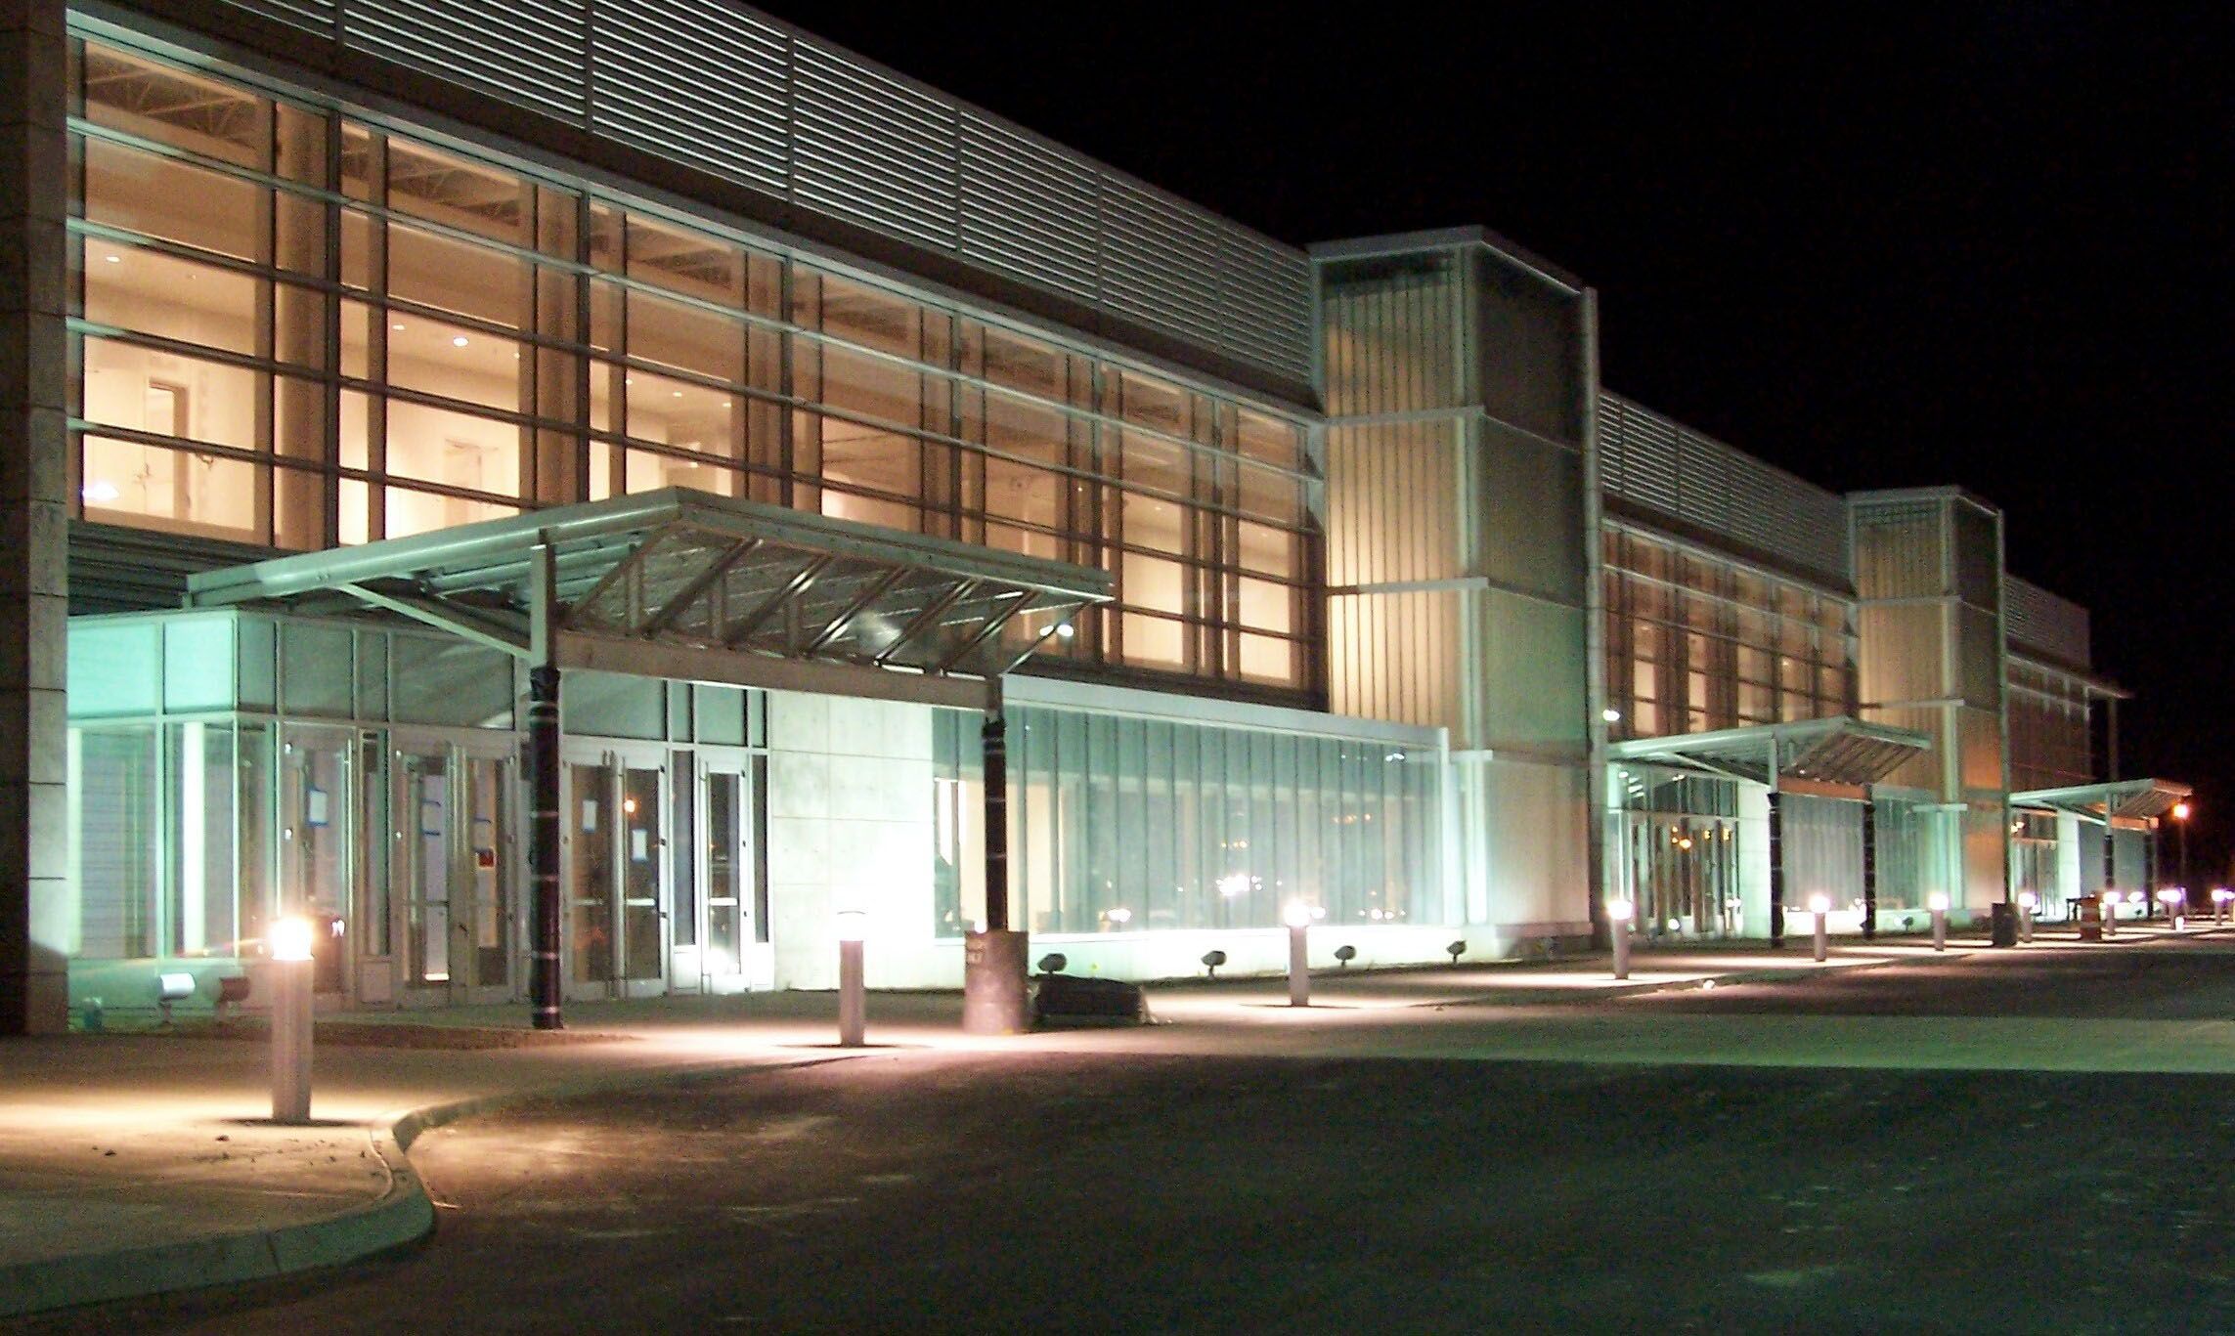

Audio-Visual Services
Presentation Services (PSAV) is the in-house audiovisual provider for the HRCC. PSAV can support groups with a large variety of rental equipment, sound system maintenance, meeting capture and video conferencing. For a complimentary estimate, please contact Travis Grenier: Office (757) 825-4925, Mobile: 757-325-7529, or via email at tgrenier@psav.com.

Decorator Services
Exhibits Inc is the preferred decorator for the HRCC. They offer services and products that include, but not limited to, pipe and drape, booth equipment, floor plan drawings, registration counters, carpeting, drayage, and freight services. To learn more about how they can be of service to you, please call (804) 788-4400, or send an email to customerservice@xhibitsinc.com.

Event Manager
Following the execution of the Lease agreement for your event, the HRCC will assign an Event Manager to work with you on event planning and implementation. The Event Manager will contact you as soon as assigned and will remain your primary client liaison through the conclusion of your event.
The major function of your Event Manager is to gather all event information and disseminate that information to our in-house operating departments. Once agreements are finalized with the Food and Beverage Office, your Event Manager will work closely with your Catering Coordinator in developing floor diagrams for your catered functions.
We strongly encourage you to have a site inspection, and request that arrangements be made in advance to assist us with the coordination of any in-house guests during this period and to enable us to prepare for your needs. Our staff will make every attempt to arrange site inspections in advance on non-event days. However, if a site inspection occurs on your event day and requires access to space utilized by your event, your Event Manager will ask your permission to show your authorized space.
Please communicate regularly with your Event Manager during the planning process to ensure the successful production of your event.

Event Services Estimate
Your Event Manager will provide you with an estimate of charges once all of your event requirements have been received. An event services estimate will be issued to the Licensee approximately thirty (30) days prior to the event. We ask that the Licensee sign and return the cover page to the Event Manager upon receipt. One hundred percent (100%) of estimated special event charges are due at this time. Please provide the HRCC with a credit card number to be kept on file for any additional charges.

Services and facilities
included in rental
- Public Space
- 100% house lighting and HVAC during show hours
- Customary work lighting during move-in and move-out hours
- Registration space upon availability

Exhibit Halls
- Show office space upon availability
- Exhibit hall public address system with microphone

Meeting Rooms
- head table of (6) with skirting on
- (1) riser
- (1) Podium
- (1) Corded Microphone
- Tables and Chairs

Ballrooms
- VIP Room upon availability.

Services and facilities not included in rental
- Police Detail (event and traffic related)
- Security
- Cleaning
- Medical Personnel
- Fire Marshall (if necessary)
- Box Office Service & Personnel
- Ticket Takers/Ushers
- Event Utility Services
- Special equipment such as staging, dance floors, rigging of signs, etc.

Any changes to the initial meeting room set during the course of a day is subject to the prevailing labor and equipment rate. There is no fee for normal overnight changes discussed 72 hours prior to the start of the event. If overnight changes are not discussed 72 hours prior to the start of the event a changeover fee will be applied to your final settlement.

Parking
The HRCC has over 4,000 surface parking spaces available for event use. These spaces are shared with the Hampton Coliseum and operate on a first-come-first-serve basis.

Media Parking
Media vehicles may park within the HRCC loading dock or designated parking areas. Media vehicles may not park in Facilities turnouts or at entrances to facility without prior approval.
Loading Dock Parking
Parking at loading docks is restricted to authorized personnel only. Dock passes may be issued on a limited basis through the Event Services Department. Vehicles must display the dock-parking pass on the dashboard and must comply with all customary parking regulations or be subject to removal at owner’s expense. Your Event Manager will meet with you to determine appropriate dock locations for vehicles to unload or load during move-in and move-out periods.
HRCC requires an off-duty Hampton Police Officer or dock-master on the loading dock during the event move-in and move-out.

Security
Lessee is responsible for complete security within the contacted areas in use by lessee. The HRCC maintains security for building perimeter areas and internal patrols. Lessee IS REQUIRED TO PROVIDE SECURITY in loading dock areas; emergency exits, meeting rooms, ballrooms and other leased areas from the time of initial occupancy until completion of move-out. Such services, when required, will be at the expense of the lessee. The HRCC’s standard for security is (ONE) Security Guard for every (500) guest/attendees. Should there be an event with alcohol, additional police or security may be required.
In the event that you wish to provide your own contracted security, please contact your Event Manager for details and requirements. ALL security arrangements are subject to approval by HRCC Management.
Any security company hired by the lessee must be licensed, insured and bonded in the state of Virginia.
The HRCC reserves the right to require an appropriate number of Police Officers for all public and private events. The HRCC requires all public shows with over (2,500) attendees per day to contract (2) Police Officers for the duration of event hours that will be billed back to the lessee.
Contracted security firms shall submit a Comprehensive Security Plan along with security floor plans to the HRCC Events Services Department fourteen (14) days prior to event move-in. These are subject to review by HRCC Management. All plans will remain confidential.
The Security Plan shall include all post locations, dates and times positions will be staffed and a listing of all exhibit booth posts requested by individual exhibitors. Any changes made to the plan after approval will require additional review. The Event Services Department will be notified of any on-site changes.
Contracted Security is to provide copies of all incident reports regarding crimes, illness or injury occurring on HRCC property including any facility damages.
Contracted security/ Show Management will allow authorized HRCC employees access to contracted space to allow maintenance of space and inspection of the event.
Abusive language, threats, assault, public drunkenness, vandalism, theft or any other inappropriate actions that threaten public safety and proper operation of event will result in immediate removal from the premises or arrest and prosecution when appropriate.
The HRCC Security Department should be contacted in the event of a crime, medical or other emergency situation. HRCC Security in accordance with HRCC Emergency Operating Procedures shall make all calls to outside emergency agencies. Copies of the procedures are available upon request.
Chain locks and other devices, which secure mandatory fire exit doors, are strictly prohibited.
Compliance with O.S.H.A. regulations is the responsibility of the lessee and their contractor.

Firearms Policy
Security Firm personnel engaged by the lessee are prohibited from carrying firearms unless personnel are authorized uniformed law enforcement officers having jurisdiction.

Badges
It is important that each individual, including exhibitors, service contractor personnel, technical crews, etc. contracted for your event is issued a dated badge for building access. Please provide your Event Manager with samples of event badges before the first move-in day.

All HRCC personnel will have picture ID cards and/or will be uniformed. HRCC staff will have access to all leased spaces for cleaning, and event monitoring.

Utilities

The main exhibit hall provides electric services in floor boxes located on 30’x30’ centers. Detailed technical specifications can be found in the Appendix. Air, water and drain service is conveniently available through access points located in exhibit hall floor box. Electrical service is available, upon request, in all meeting rooms. Utilization of permanent wall outlets, servicing 120 volts / 20 amps, may be used by any client or contractor in all meeting rooms without charge.

Electrical and plumbing services are offered exclusively through the Hampton Roads Convention Center utilities department. Your Event Manager will supply a copy of the utility services order form which should be included in your exhibitor kits.

The HRCC will require groups with water connections over 100 gals. to cover a deposit made to Newport News Water Works for a water meter. Please Contact your Event Manager for more information.

Facility Event Services

- Box Office
Box Office services are available through the HRCC at a cost based on the operation hours and staffing required. An off-duty Hampton Police Officer is required for all public ticketed events, whether the client or the HRCC operates the box office. Lessee shall be responsible for all required licenses and pay all admission taxes required by any government regulation. Contact your Event Manager for additional information.
- Coat & Baggage Check
Coat and Baggage Check Services are not offered through the HRCC. Lessee has the option of securing an outside provider to offer these services.
- Computer Connections
The HRCC is outfitted with data connections. The facility has connections incorporated into all meeting rooms, exhibit halls and likely registration areas to make LAN connections for your event. Complimentary Wi-fi is offered in the common areas. Wi-fi service inside your meeting rooms is available for a fee. Your Event Manager can provide prevailing rates.
- Concessions
You may arrange to have concessions available during your event. Daily minimums apply. Please discuss this option with your Event Manager.
- Equipment Inventory and Rental
The HRCC will make its best effort to accommodate the needs of all events, although, equipment is available as inventory permits. The costs for supplemental equipment may vary based on quantity and availability.
- Event Staffing
Our in-house staffing service can provide ushers, door guards, dock guards and ticket takers for an additional charge. The in-house ushering service provides qualified, uniformed staffs that are familiar with the facilities and with event needs. Ticketed events and some public events will require the use of the in-house ushering staff. Contact your Event Manager for specific event requirements. Your Event Manager can provide rates and staffing levels and make arrangements for event coverage.
- First Aid
The Center requires contracted EMT services for events. Events that will require an EMT on-site include:
(750) or more during meeting hours OR events with meal service of (500) or more with no alcohol OR events with (400) or more AND with alcohol service. All sporting events require at least one EMT from the Center.

The General Manager retains discretion to require EMT, based upon activities or demographics of any event regardless of the above stated parameters. The Convention Center requires all required EMT services to be at the customer’s expense. Please contact your Event Manager for approved EMT companies.

- Food and Beverage Services
The Embassy Suites is the exclusive caterer for the HRCC and provides a wide selection of heart-healthy, vegetarian, vegan, International and hearty American menus for your event. A Food and Beverage specialist will also prepare and help you customize your own menu. For more information, please contact the Sales & Catering Department at (757) 827-8200.
- Hampton Convention & Visitor Bureau
Along with the services offered by the HRCC, the Hampton Convention & Visitors Bureau can offer a wide array of citywide services for your event. The Bureau can be reached at 757-722-1222 and is ready, willing and able to help you with your offsite needs.

- Information Desk/Guest Services
The complimentary HRCC Information Desk provides information for restaurants, shopping areas, entertainment and attractions located within the Hampton Roads area. The information desk will be available only during event hours and can be staffed through the Hampton CVB. Your Event Manager can arrange for this service.
- Information Kiosks
The interior of the HRCC is equipped with three (3) information kiosks. We will display your event title, date and location on these screens. The touch information screen, located at the main entrance of the HRCC, displays event publicity and local amenities, including, hotels, restaurants, attractions, and travel information.
- Paging System
A paging system with one standard microphone is available without charge (upon request) in exhibit halls. Arrangements can be made in advance to page multiple locations and may involve an additional charge. HRCC reserves the right to make announcements over the system at any time to communicate information pertaining to public safety, law enforcement, and the operation of the facilities.
- Registration Space
Registration space, as required by lessee and in consideration of other tenants, will be provided at no charge.
Registration equipment, telephones and electrical services are not included. Registration plans and space utilization MUST BE APPROVED IN ADVANCE.

- Show Manager’s Office
A Show Manager’s Office is located in every exhibit hall for your exclusive use. Contact your Event Manager for information and rates on any supplies that may be needed.
- Telephone Service
HRCC office telephones are reserved exclusively for Convention Center business. THE HRCC NUMBER MAY NOT BE PUBLISHED AS AN OFFICIAL SHOW OR CONVENTION NUMBER. Complete telephone service is available on the exhibit floor, in show offices, registration areas, meeting rooms, ballrooms, etc. Contact your Event Manager for more information.

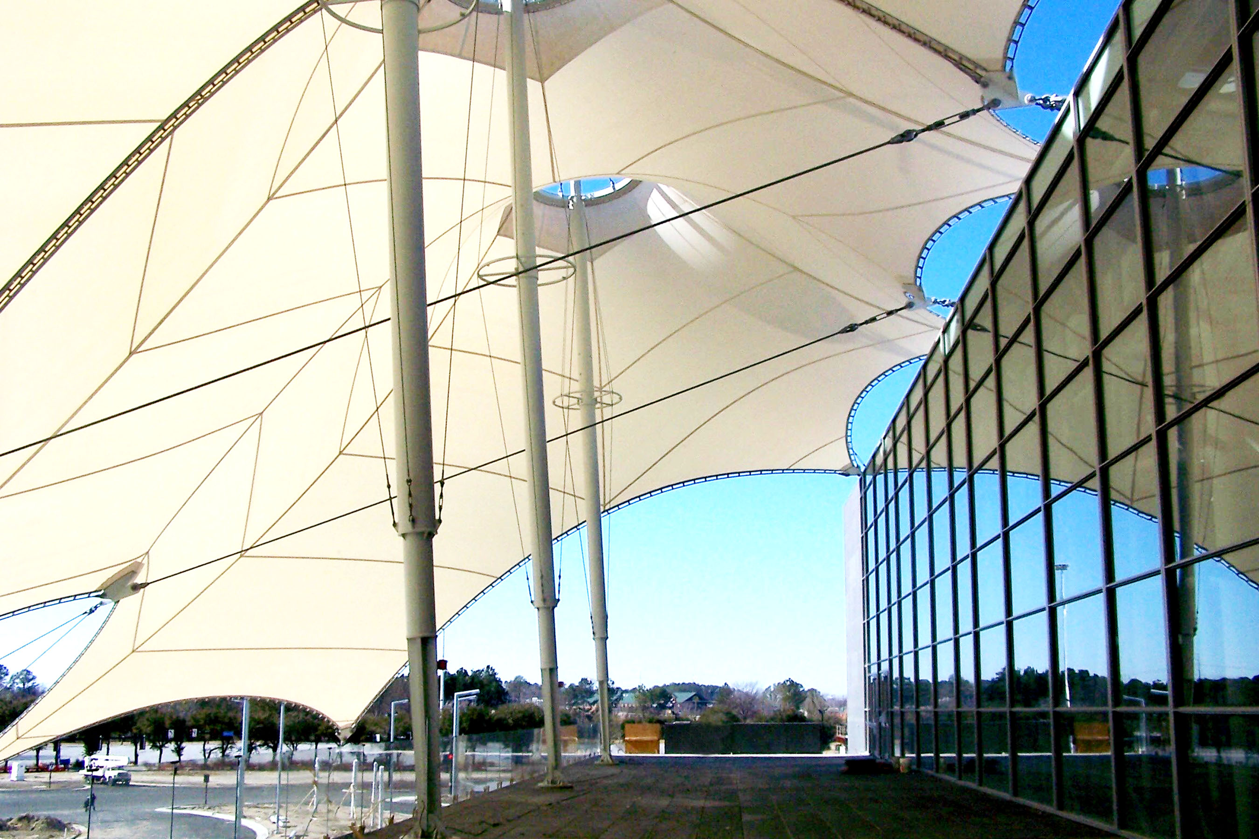

Facility Operations Guidelines

- Abandoned Equipment
All equipment, decorations, freight, etc. must be removed from the premises at the expiration of the Lessee’s contract. Items left beyond this time will be treated as abandoned equipment and disposed of as the facility sees fit. The HRCC shall assume no responsibility for losses suffered by the Lessee or his agents occasioned by theft or disappearance of this or any other equipment, articles, or property.
- Access
While the HRCC has full service security 24 hours a day/7 days a week, access to the HRCC is restricted during off-event hours. On a normal event day, the HRCC will be open 8am-5pm unless otherwise arranged with your Event Manager.
- Adhesive Backed Decals
The HRCC does not permit the use or distribution of Adhesive Baked Decals within the limits of the grounds.
- Air Conditioning
Air Conditioning is provided only during open show hours on the exhibit floor and during seminar hours in meeting rooms. Air conditioning is not automatically available on the exhibit floor during move-in and move-out hours as freight doors will be open during that time. Should air conditioning be required in meeting rooms or exhibit hall other than scheduled seminar or show hours, your Event Manager can provide you with the cost.
- Alcohol
HRCC or its agent will be the exclusive vendor of alcoholic beverages within the facility unless specific arrangements are made with HRCC Management. Alcoholic beverages will not be served to minors or to persons who appear intoxicated. No alcoholic beverages are allowed in the exhibit halls during move-in or move-out. HRCC reserves the right to terminate the service of alcoholic beverages if your event is in violation of Federal, State, County or City laws relating to the service of alcoholic beverages or if deemed to be necessary for public safety reasons.
- Amendments
HRCC Management shall determine any matters not expressly covered by the following guidelines. The HRCC reserves the right to alter or amend these guidelines at any time.
- American with Disabilities Act
The HRCC is ADA compliant. As new standards are introduced, it is our goal to implement those changes or upgrades in a timely manner. In accordance with the ADA, we are responsible for permanent premises access accommodations, such as, but not limited to, wheelchair ramps, elevator standards, door width standards and restroom accessibility. It is your responsibility to provide non-permanent accessibility requirements, such as, but not limited to, hearing-assisted or visually assisted devices, and temporary seating accessibility and/or interpreters. HRCC maintains a limited amount of portable stage ramps and related items.

- Animals
Animals are not permitted within the facility except as an aid to people with disabilities, or with special permission from facility management.
- Business Licenses/Health Permits/Taxes
It is Lessee’s responsibility to procure all necessary licenses and/or permits, business license, health permits, fire permits, etc. The HRCC will assist you in providing Center-related information necessary for submission, but cannot secure licenses/permits on behalf of Show Management. All required state and local taxes will be collected by the HRCC.
- Cleaning and Custodial Service
The HRCC staff provides general housekeeping, including trash removal, for uncarpeted aisles and corridors in the exhibit area, in areas used for meetings, and in public areas, during show hours. Meeting rooms are cleaned prior to and after each day of use. Upon request, rooms are refreshed during adequate break times. Materials left overnight are discarded unless otherwise instructed.
If an event generates excessive amounts of trash, show management should advise their Event Manager in advance so that additional bins may be ordered. Excessive trash is considered trash that exceeds one forty-yard open bin container per event. Lessee will incur charges for additional bins and dumpster pulls. Your service contractor is responsible for cleaning loading dock areas and show floor of all excessive trash, debris, skids, and equipment related to your event. Failure to do so will result in additional charges to the event for the costs of cleaning the dock area and show floor.
- Conduct
Lessee is responsible for the conduct of its employees, agents, and attendees. If any such person fails to comply with applicable rules and regulations, the HRCC may restrict the use of the premises or entirely bar the lessee from the building.
- Cooking Regulations
Cooking in exhibit booths is permitted in the building on a limited basis and only with the approval of HRCC Management. Only hot plates or self contained single unit LP burners are permitted. Any other forms of cooking will require the approval of HRCC Management and the Fire Marshall. Fire extinguishers are required in all areas dedicated for cooking.
- Crate Storage
The HRCC does not provide exhibit crate storage. Lessee and lessee's service contractor are expected to make arrangements for storage of all crates and packing materials.
- Damages
Lessee is responsible for any damages to the building, furnishings, grounds, or equipment. Lessee and lessee's contractors are requested to accompany a facility representative on a pre-move-in and post-move-out tour of the facility to assess any damages and determine responsibility.
No damage to the premises observed during the inspection may subsequently be asserted by the licensee to have occurred prior to his event unless reported to your Event Manager prior to move-in. Should building damages occur during an event, your Event Manager will notify you of the damage. Charges for damages will be included in your final event settlement.
- Decorations, Banners and Posters
Decorations may not be taped, tacked, or otherwise fastened to ceilings, painted surfaces, columns, or fabric and decorative walls. Special decorations are to be cleared through the HRCC Management as to method and location of installation. No helium balloons or adhesive backed decals are permitted to be given out or used within the facility. All decorative materials must be flameproof in accordance with local Fire Regulations.
Glitter may not be used in any area of the facility. HRCC management must approve the use of confetti.
- Elevators and Escalators
Escalators and passenger elevators are for use by the public and may not be blocked or used to transport equipment and freight. HRCC Security will monitor activity on escalators to ensure public safety during high traffic events. Additional staffing may be required to monitor escalators if traffic is determined to warrant it.
- Event Plan
A basic Event Plan outlining event related information and facility needs is required 60 days prior to event move-in. A comprehensive Event Plan must be submitted to your Event Manager no later than 30 days prior to the first move-in date and should include the following information:
- Registration or admission information, anticipated attendance
- Publicity information
- A timeline of all activities, including decorator, vendor and rehearsal times
- Room set-up requirements
- Room set-up changes
- Sound & lighting requirements
- Telephone installation requirements
- A/V equipment requirements
- Food & Beverage requirements
- Utility Service requirements
- Staffing plans and requirements
- Parking and transportation plans
- Signage plans
- Contact names & phone numbers for key event staff members
- Contact names & phone numbers for all contractors providing services
Your final event plan, which includes meeting room set-ups, is to be provided to your Event Manager twenty-one (21) days before your first move-in day. Any changes within (21) days prior to the first date of your event may be assessed additional late charges for staff time. Requests for adjustments after set-up will be handled as expeditiously as possible and you will be advised, when possible, of the approximate cost of those changes. HRCC reserves the right to charge for excessive, unplanned changes or numerous changes per day.
Many events require pre-event and post-event meetings with the Event Manager and other in-house personnel (audio-visual, Hotels, sales, security, operations, etc.). Contact your Event Manager to discuss whether a pre-event and/or post-event meeting is necessary. You should attend the pre-event meeting with your major contractors (service contractor, audio-visual company, security company, room monitor staff, etc.) and key event organizers (exhibit managers, meeting coordinators, meeting planner, etc.).
We prefer to conduct post-event meetings before you leave the facility on the last day of your event. Meeting details and agendas can be arranged through your Event Manager.
- Fire Code Regulations
Listed below are the most common Fire Code Regulations that pertain to events in the HRCC. Not all regulations are listed. If there is a concern regarding an exhibit or event, please contact your Event Manager.
Show management, exhibitors, service contractors and all other involved parties must comply with all Federal, State and municipal fire codes that apply to places of public assembly.
Sections of the Life Safety Code Book, which are pertinent to places of public assembly, shall be considered part of all leases whether specifically referenced or not.
All drapes, curtains, table coverings and skirts, carpet or any materials used in exhibits must be flame retardant. Flame retardant chemical certificates must be current and available to the Fire Marshall upon request. All such material is subject to flame testing by the Fire Marshall. Fire fighting and emergency equipment may not be hidden or obstructed, including fire extinguishers and fire hose cabinets, fire alarm pull stations, standpipes and exit signs.
Exhibit booths and other structures, constructed within an area equipped with an automatic sprinkler system, shall not be constructed with any roof, ceiling, or other enclosure which would prevent the sprinkler system from protecting the booth area. For approved canopy structures, contact the Fire Marshall. Any multi-level booth may require approval by the City of Hampton Fire Department and may require floor plans in advance.
Crates, wooden boxes, packing material, etc., may not be stored in public spaces, meeting rooms, ballrooms or exit areas. Lessee and Service Contractors are expected to make arrangements for proper storage of all crates and packing material.
Vehicles with gasoline engines may be displayed with a maximum of ¼ of a tank of gas remaining in the tank. No fuel may be drained in the facility or on the loading dock. Show management should make prior arrangements with a service station, or similar facility, that exhibitors may use. A locking gas cap must be installed or the tank must be adequately sealed by tape or in some other appropriate manner. All battery cables must be disconnected and taped to avoid potential sparks. No vehicles may be moved during event hours. Liquid petroleum fuel tanks shall be removed.
No gasoline, kerosene, diesel fuel or other flammable liquids may be stored, permanently or temporarily, inside the facility. Refueling must be done a minimum of fifty (50) feet beyond the exterior of the facility.
Access to fire exit doors, corridors, switch gear, fire hose cabinets, standpipes, extinguishers and alarms must remain visible and accessible at all times.
The use of pyrotechnics, welding equipment, open flames or smoke emitting material as part of an exhibit must be specifically approved on an individual basis by the City of Hampton Fire Department. Written specifications must be submitted to Event Services to request Fire Department approval.
Depending on the event, extra fire extinguishers may be required by the Fire Marshall at the expense of the Lessee.
No storage of exhibit materials is permitted in the utility aisle behind the booth.
Propane tanks are not permitted in the HRCC without written approval of the Hampton Fire Department.
The exhibit halls, ballrooms and meetings rooms have limited areas for storage. Corridors are designated as fire exits and may not be used to store equipment of any kind.
- Floor Marking/Carpet Tape
Contractors and vendors shall use standard stick or ball type chalk, or non-residue marking tape (Bron BT 100) in marking spaces. Liquid chalk, water paint, liquids, double faced tape, heat tape, and duct tape are expressly forbidden. All tape must be removed from the floor and disposed of immediately after the event. The lessee and lessee’s contractors are responsible for the removal of tape residue marks on the exhibit floor and/or HRCC equipment. Cost of removing the markings will be the responsibility of the Licensee.
- Floor Plans
Detailed floor plans are required for exhibit halls and registration or special activities and exhibits scheduled in any public areas of the facility, including exhibits located in meeting rooms and ballrooms. These floor plans should be reviewed with the Event Services Department prior to confirming exhibit space. Event Services will notify show management and their service contractor of problem areas and required modifications. Event Services will submit plans for final approval to the Hampton Fire Marshall. All exhibit floor or registration plans should include the following information:
- Official name of the show, sponsoring organizations, dates and name of service contractor.
- All plans should be drawn to scale.
- Primary entrance doors and emergency exits should be readily determined.
- Service desk locations should be indicated.
- Service contractor storage areas or "bone yards" should be clearly marked if located on floor.
- Note if aisles are to be carpeted.
- Distinction between pipe and drape or hard wall should be indicated.
- Temporary exhibit floor food service areas should be clearly indicated.
- The following specifications are required for submitted floor plans:
- All points of ingress and egress should have a minimum of 10’ clear space on all sides
- Aisle widths should be clearly indicated.
- All cross aisles must be a minimum of 8’ wide
- All perimeter aisles must be a minimum of 10’ wide
- Fire hoses, extinguishers and standpipe cabinets must be kept clear of obstructions
- No visual or physical obstructions to fire exit doors are permissible
- Building graphics, restroom and storage areas must not be blocked
- A minimum of 20’ aisle must be maintained in front of concession stands (If in use).
- Food & Beverage Sampling
If show management has exhibitors who wish to provide food samples at appropriate events, then prior written consent must be obtained from HRCC Management. Exhibitors must also obtain a temporary health permit through the Hampton Health Department (See Appendix). Food samples are limited to bite size containers.
- Freight Deliveries/Receiving
The HRCC CANNOT accept advance freight shipments for exhibitors or meetings. Freight must be consigned to the official show service contractor or delivered directly to the service contractor during the lease period. Exhibitor freight that arrives prior to events will be directed to the event decorator or freight forwarding company, or refused and instructed to return during the lease term. The HRCC can accept up to ten (10) boxes from the show manager with a combined weight of 100 pounds. Additional boxes or freight will be charged accordingly. Please address packages to the attention of your event name.
- Freight Elevators
Equipment, freight, and deliveries must be transported on service elevators located in the loading dock area. It is the responsibility of the Lessee, and its agents to observe load capacities. The HRCC reserves the right to operate or require an operator for freight elevators.
- Furniture and Equipment
The HRCC does not provide furniture or equipment for use in exhibit booths. All arrangements for exhibit hall and lounge furniture should be made through a service contractor. Planters, furniture and other permanent HRCC equipment may not be used or moved into show areas. HRCC provides standard furniture for show management offices. When a service contractor is being used, all furniture for exhibitors and additional furniture for show management should be supplied by the service contractor. Furniture modules in the concourse areas are arranged for the convenience of attendees for all events at the HRCC. Although HRCC discourages requests to move this furniture, accommodations may be made through your Event Manager if the arrangement does not impede the use of the pre-function space for other attendees. This service will incur an additional charge.
- Gratuities
The HRCC staff prides ourselves on our ability to provide you with the best service possible. No gratuities are expected or allowed. If you feel so inclined, letters of commendation recognizing employees for outstanding service may be sent to the General Manager.
- Inventory
When HRCC inventory has been depleted, it is the lessee’s responsibility to rent additional equipment from a service contractor or an outside vendor. All equipment is subject to first come first serve bases.
- Inspections
The HRCC reserves the right to inspect any carton, satchel, container, briefcase, luggage, or package, brought into or taken out of the HRCC.
- Insurance
A policy suited to your event must be in place, naming the HRCC, the City of Hampton, and SMG as additionally insured, before your event can take place. Your certificate of insurance must be submitted to your Event Manager 5 business days before the start of your event. Your Sales Manager will explain the details to you.
- Lasers
Lasers are permitted in the HRCC. You must comply with all fire regulations, safety codes and facility policies regarding the use of lasers. Arrangements for electrical power, water sources, water drainage, water pressure, water recycling processes and the use of smoke or fog machines should be discussed in advance with your Event Manager. Only water based fog machines are permitted. Additional charges for water connections and water use fees apply. Alternative water resources may be required by HRCC.
The presence of an on-site Fire Marshal may be required at your expense if, by using lasers, the ventilation and fire alarm systems have to be turned off during the laser performance.
- Motorized Vehicles
Vehicles are permitted in the exhibit halls for the purpose of loading and unloading. Display vehicles must conform to State and City fire code. Motorized vehicles, forklifts, gas or electric carts, etc., may not be operated in pre-function areas or any carpeted area of the HRCC, unless approved protective floor covering has been placed in said areas.
Your Event Manager must be notified in advance if motorized vehicles are to be displayed during an event. Displayed motorized vehicles shall comply with the following and may also have to comply with any additional rules and regulations required by the Fire Marshal:
- No vehicle may be started or operated within the facility during show hours.
- All fuel tank openings shall be locked or sealed in an approved manner to prevent escape of vapors.
- Batteries shall be disconnected. Connections shall be taped to prevent arcing.
- Adding or removing fuel, on site, is prohibited.
- A vehicle key may be left in the Security Control Office for emergencies.
- No more than ¼ of a tank of fuel may be in the tank
- No fuel may be drained in the facility or on the loading dock. Show management should make prior arrangements with a service station, or similar facility, that exhibitors may use to remove fuel from vehicles
- Exhibit Hall doors cannot be opened to the public without the above conditions being met.
- Move In/Move Out
Move In - Move Out hours are normally from 8:00 A.M. - 5:00 P.M. daily. Variations from these hours shall be negotiated with HRCC Management.
- Novelty and Concessionaries
Novelty sales must be arranged in advance with the Event Manager. Appropriate licenses, commissions, and insurance forms may be required.
- O.S.H.A. Regulations
Compliance with O.S.H.A. regulations is the responsibility of the lessee and lessee's contractors.
- Overhead Doors
Overhead doors will be operated by HRCC personnel only and will be available after prior arrangement with your Event Manager.
- Portable Walls
The configuration of the acoustical operable wall panels at the HRCC is complex and alterations may be time-consuming. Any proposed changes should be planned in advance with your Event Manager. Last-minute changes can negatively impact other room set-ups in progress at the time. Your Event Manager will assist you in determining if changes, planned or unplanned, are possible, and if any cost is involved in changing the wall panels. No walls may be moved by anyone other than HRCC staff.
- Public & Common Areas
The pre-function areas and permanent food facilities are considered public areas and generally not under Lessee control. All activities utilizing public areas, such as registration, special exhibits or displays, etc., must be approved in advance. Detailed floor plans with specifications are to be submitted to Event Services for approval. Activities in public areas must take into consideration the requirements of other tenants utilizing the facility. Service desks and related "behind the scenes" work stations should not be set in public areas.
- Refunds
The HRCC reserves the right to determine whether ticket receipts shall be refunded for cause. In making such determinations, the HRCC may consider the interest of the facility in protecting its public goodwill. Show Management will be notified of any refunds deemed necessary by the HRCC.

Returned Check Policy
Checks returned to the HRCC for a closed account or insufficient funds are subject to a $35 service charge, over and above the amount of the original check, payable immediately.

Rigging
All rigging or any other attachments to the facility’s ceilings, with the exception of lightweight banners, will be performed by an approved vendor. Plans and specifications for all proposed rigging installations shall be prepared by the lessee and submitted to the Event Services Department. This information should be submitted at least 30 days in advance of the event. Rigging plans must show all attachment details. The Event Manager will discuss the detailed plans for the event and make recommendations and suggestions for installation.
No modifications or alterations to the building’s structure or interior finishes by outside audiovisual companies or service contractors are permitted. If modifications are required, pending HRCC approval, these modifications will be performed by, or be under the supervision of HRCC personnel. This includes, but is not limited to, such items as removal of ceiling tile or track lighting fixtures (fixed or portable), modification of doors and hardware, cutting and/or drilling holes in drywall or masonry, removal or relocation of permanent draperies, and installation of floor anchors.
- Room Capacities
All exhibits, equipment, displays, etc. must observe the floor load capacities of the HRCC. All meeting rooms and exhibit halls have a posted maximum occupant capacity and it is the responsibility of the licensee to observe such limitations. The HRCC reserves the right to close any area to occupancy if, in its opinion, public safety is in jeopardy or damage to the facility may occur.

Safety
Unsafe conduct or conditions including maintenance hazards should be reported immediately to HRCC Security.
Oil spills, loose or missing floor box covers and other apparent safety hazards should be reported immediately to HRCC Security.
Passenger elevators and escalators shall not be used to transport freight, including hand trucks, floats or similar equipment.
- Settlement
It is the policy of the Hampton Roads Convention Center that all settlements of events will be finalized at the end of the event. At that time, payment of any additional services, equipment or fees will be due.
If the client is due funds from ticket sales or other sales, a check will be mailed to them within 14 business days.
- Signage
Hampton Roads Convention Center’s permanent graphics, signs or displays may not be visibly blocked in any manner nor may temporary signs or decorations be attached to permanent building graphics. Exterior signs and banners may not be fastened to the building superstructure. Temporary exterior directional, information, shuttle bus signs, etc., must be approved in advance by HRCC Management.

Smoking Policy
The Hampton Roads Convention Center is a non-smoking facility. Outside smoking areas are available on the 1st and 2nd floors. E-cigarettes and Vapes are not permitted in the building.

Solicitations
The General Manager must approve all event solicitations (i.e. signatures, services, donations, etc.). Solicitation requests should be made in writing to the Event Manager 30 days in advance of your event.

Sound/Lighting
A sound/light technician may be required to coordinate the use of house sound and lighting systems. The cost for the technician is the responsibility of the Lessee. A charge will be assessed to outside AV companies tying into the HRCC sound system.
HRCC personnel shall perform all major utility connections, removals, and relocations of HRCC lighting, sound and electrical systems.
Audio-visual and Production companies shall make all arrangements for any lift equipment, other than that available through the HRCC, necessary to install sets. Delivery of equipment must be coordinated with the Event Manager. All lifts must be stored in approved locations or removed from the premises.
- Taxes
Show Management and exhibitors are responsible for all taxes payable to the State of Virginia and/or the City of Hampton. Any entity, event or exhibitor selling product in the state of Virginia must be in compliance with all of the taxation rules and regulations of the State of Virginia.
Please visit www.tax.virginia.gov and www.hampton.va.us/assess_and_collect/rent.html for more information.

Truck Marshalling
Please contact your Event Manager to discuss the best Truck Marshalling options for your event.

Waste Materials
Under no circumstances may grease or other waste material be poured into drains or receptacles. Grease and any hazardous material must be removed by the Lessee in proper containers.

Events or circumstances not covered in these operating policies and procedures may be subject to special consideration and stipulations as deemed appropriate by Hampton Roads Convention Center Management. By signing below, I hereby acknowledge that I have completely read and fully understand the above information. My signature also certifies my understanding of and agreement with the above policies.
_________________________________Client Signature ______________________________ Today’s Date

Appendix

Credit Card Authorization Form A
Event Planning Checklist B
Insurance C
Sample Insurance Certificate D
Hampton Health Department E
Ticketing Guidelines………………………………………………………………………….F

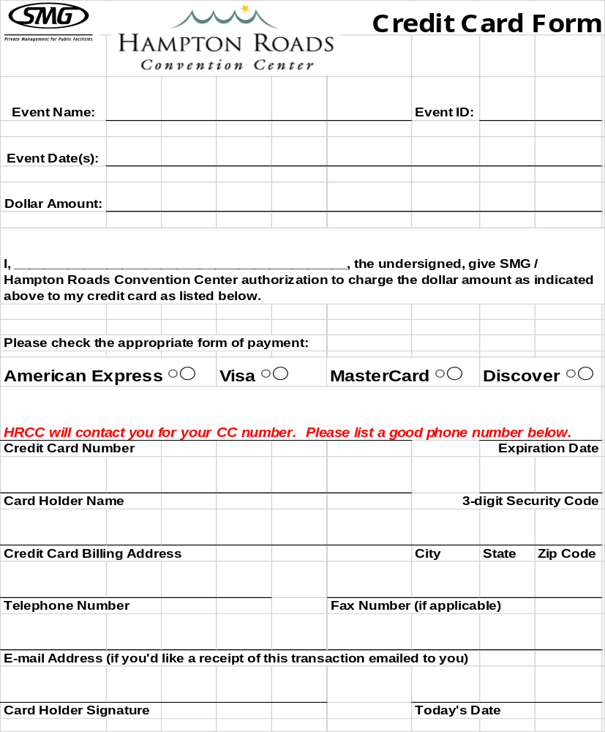
Event Planning Checklist
Appendix B

This checklist is designed to assist you in your planning process.
Adhering to this schedule is critical to ensuring a successful event.

12 Months Out
- Provide a copy of last year’s annual meetings and convention resume
- Place your Event Manager and Catering Sales Manager on your mailing list
9 Months Out
- Provide a copy of your initial floor plan and event schedule to your Event Manager
6 Months Out
- Schedule a site visit/planning meeting with your Event Manager
- Submit an exhibitor service kit and exhibitor list
- Provide a copy of your revised floor plan and schedule to your Event Manager
- Discuss preliminary food and beverage needs with your Catering Sales Manager
3 Months Out
- Submit rigging plans for consideration
- Submit your Audio-visual requests
- Contact your Event Manager to discuss your event security requirements
2 Months Out
- Submit your preliminary meeting room & ballroom(s) schedule and set-up requirements for review
- Schedule pre- and post-convention meetings with Event Manager
1 Month Out
- Certificate of insurance is due
- Final exhibit hall and registration floor plans are due
- Final exhibit hall schedule is due
- Final meeting room and ballroom(s) schedule and set-up requirements are due
- All utility service order forms are due
- All telecommunication service order forms are due
- All exhibition services cleaning order forms are due
- Final rigging requests/plans are due
- All event services order forms are due
Insurance
Customer Service Flow Chart

Hampton Roads Convention Center
Requirements for License of Convention Center Facilities

In accordance with [paragraph E of the License Agreement] titled Insurance, of your license with the HRCC, all licensees and their subcontractors are required to provide a Certificate of Insurance evidencing the required coverage. A Certificate of Insurance complying with the following requirements is due in our office at least thirty (30) days in advance of your event.

Additional Insured – The Certificate of Insurance of the policy shall contain the following mandatory endorsement:

“ADDITIONAL INSURED FOR LIABILITY COVERAGE, EXCEPT FOR PREMIUM PAYMENT OBLIGATION, SHALL INCLUDE SMG AND THE CITY OF HAMPTON AND ALL DEPARTMENTS, BOARDS OR COMMITTEES ESTABLISHED BY IT OR UNDER ITS CONTROL. THIS INSURANCE IS PRIMARY TO ANY OTHER VALID OR COLLECTABLE INSURANCE OR SELF-INSURANCE, WHETHER OR NOT SUCH OTHER INSURANCE OR SELF-INSURANCE, IS PRIMARY, CONTRIBUTORY OR EXCESS. THIS INSURANCE SHALL APPLY TO EACH NAMED ENSURED FOR OCCURRENCES TAKING PLACE DURING THE TERM OF THE LEASE IN ALL AREAS OF THE HAMPTON ROADS CONVENTION CENTER IN WHICH ANY ACTIVITIES CONNECTED WITH THE LEASE BETWEEN THE PARTIES TAKE PLACE”.
Appendix C

Limit of Liability – Minimum $2,000,000.00 CSL per occurrence, in the exhibit halls and minimum $1,000,000.00 CSL per occurrence in the meeting rooms. The total limits can include coverage under an Excess Liability Policy.

Coverage To Be Provided – Comprehensive General Liability including:
- Premises Operations
- Blanket Contractual Liability
- Broad Form Property Damage
- Products and Completed Operations
- Independent Contractors
- Personal Injury (include A, B,C)
- Fire Legal Liability
- Hired and Non-Owned Auto Liability
- Workers Compensation and Employers Liability
Note: A minimum of twenty (20) days advance written notice of cancellation or changes of coverage must be given to the Center. You may purchase insurance coverage through the HRCC Sales Department or from any insurance agency. A sample copy of the proper insurance certificate is located on the next page.

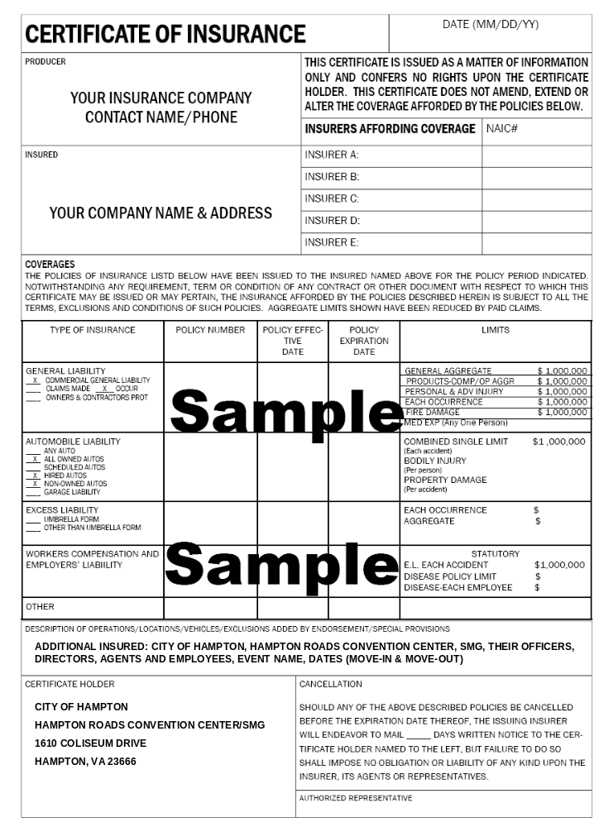
Hampton Health Department
Requirements for Temporary Food Service
Establishments at Special Events

INTRODUCTION
The following requirements are pursuant to Chapter 15 of the City of Hampton, Virginia, Ordinance and Code Regulating Food and Food Establishments, and Section 32 of the Rules and Regulations of the Board of Health, Commonwealth of Virginia, Governing Restaurants. They are intended to answer the most commonly asked questions regarding temporary food service establishments.
Please read these requirements carefully. They will include examples and alternative solutions to the most common problems found in outdoor food service concessions. For additional information, please call 727-2570.
Appendix E

REQUIREMENTS
- PERMIT
- Persons responsible for the preparation and/or serving of food (for sale, distribution or gift to the public), are required to obtain a Health Department Permit. The concessionaire will not be approved until the food concession application has been reviewed and approved by the Health Department.
- Applications for a Health Department Permit must be received at least 1 week
(5 business days) prior to each event.
C. The Health Department Permit is not transferable to another party.
- Only food items listed on the application can be sold unless changes are approved by the Health Department in advance. No changes will be accepted the day of an event.
- FEES
- As of July 1, 2002, the General Assembly passed legislation requiring an annual fee be paid by temporary food vendors. The $40.00 will be required before a Permit will be issued.
- Exemptions to the fee:
    - Churches
    - Volunteer Fire and First Aid Squads
    - School organizations
- FOOD AND BEVERAGE
- SOURCE
- NO HOME PREPARED FOODS. All food products, including beverages, ice, and water must come from a Health Department approved source (e.g. restaurant, grocery or wholesale). Baked items such as cookies, cakes, and pies are the only exception and may be prepared at home. These items, however, must be protected from external contamination by being individually wrapped, whether sold whole or sliced. Baked goods containing cream fillings are prohibited.
- All shellfish (oysters, clams, mussels) must have proper identification tags. (Shellfish Shipper I.D.’s) These tags must be made available onsite for verification purposes by the Health Department.
- TRANSPORTATION
Foods must be transported covered or wrapped and in a sanitary manner. Those food items considered potentially hazardous must be kept refrigerated below 41 degrees F or held hot above 140 degrees F during transportation. Potentially hazardous foods include, but are not limited to, such foods as meat, fish, seafood, poultry, dairy products, eggs, and pasta.
- STORAGE
- All food products and utensils (plates, cups, spoons, knives, and forks) must be stored up off of the ground (6”). Pallets, tables and empty boxes may serve as storage racks.
- No food or drink items can be stored in direct contact with undrained ice.
- Beverage containers (cans, bottles) may be stored in drained ice provided the drainage creates no nuisance. Drain the cooler into a bucket or other container for easy disposal.
- Adequate or sufficient “blue-ice” packets can be used to keep foods cold (< 41 degrees F) instead of ice.
- Storage of food, utensils or equipment in plastic “garbage bags” is prohibited. Only food-grade plastic is acceptable.
- No Styrofoam ice chests can be used. All surfaces must be of hard plastic or metal.
- Electric refrigeration, freezer or refrigerated truck is preferred if applicable and available.
- PREPARATION AND HANDLING
- All foods, unless prepared in an approved, permitted establishment, must be prepared on site. However, on site preparation should be minimized through menu selection.
- Prepackaged foods are easier, safer, and more convenient.
- The use of home-style charcoal grills is prohibited. Gas (propane or natural gas) grills are recommended.
- Potentially hazardous foods such as meat, fish, shellfish, poultry, dairy products, eggs, etc. are to be kept colder than 41 degrees F or hotter than 135 degrees F. When cooking, all foods shall be cooked to an internal temperature of at least 165 degrees F.
- Do not thaw frozen foods at air temperature. Purchase unfrozen products, thaw under refrigeration or thaw as part of the cooking process.
- Provide a stem-type thermometer to test food for proper temperatures.
- Precautions are to be taken to minimize contamination by patrons from coughing, sneezing, etc., through the use of barriers (e.g. sneeze shields, tables, barriers, etc.). All open flat top grills must have sneeze barriers in place in front of them to separate the grilling food from the public. Tables are not considered to be acceptable.
- Foods are to be served in or with single service utensils.
- Condiments:
- Individual packets or squeeze bottles are preferred.
- NO OPEN BOWLS or jars of condiments are allowed.
- Items such as chili, onions, lettuce, or tomato must be applied by an employee.
Self-service of these items is prohibited.
- EQUIPMENT AND UTENSILS
- Adequate equipment for refrigeration and hot holding of foods must be provided.
- Adequate cleaning supplies must be provided. They include: detergent, buckets, bleach and water for sanitizing equipment and utensils.
- Utensils
- Single service cups, bowls, plates, etc. must be served from the original container (e.g. plastic bag) or from an approved dispenser.
- You must provide adequate utensils such as spatulas, tongs, forks, ice scoops, etc. for handling foods.
- Single service knives, forks and spoons are to be dispensed properly from original containers or individually wrapped, or otherwise adequately protected.
- A three compartment tub setup must be provided on site to allow for the proper washing, rinsing and sanitizing of soiled utensils. A chlorine test kit (test strips) must also be provided.
- PHYSICAL FACILITIES
- Overhead protection is required over all food operations. When open flames are involved in the cooking process, the overhead protection must be fireproof in accordance with current fire codes. Fire extinguishers should also be provided. Examples include a tent, awning, or fly.
- Facilities should be designed to minimize contamination by dust, insects, etc. Ground cover in the form of plastic, a tarp, carpet, mats, canvas or other acceptable material shall be provided and placed on the ground. It must be sufficient to cover the entire area under the overhead protection that is required and provided.
- Toilet facilities must be provided and conveniently located.
- Solid Waste Disposal
- All garbage/refuse must be containerized and properly disposed of during and after the event.
- Containers for liquid waste must be provided; drainage onto the ground from ice chests, coolers, refrigerators, etc. is prohibited. All liquid waste must be disposed of properly in a sanitary sewer or other approved receptacle.
- PERSONAL HYGIENE
- A suitable means for hand-washing must be provided.
- Soap and water should be used.
- Moist towelettes / pop-up baby wipes may be used as an alternative in a concession with limited food preparation (e.g. hot dogs, popcorn, etc.). This must be approved by the Health Department on a case by case basis.
3. Plastic gloves must be worn whenever food is handled directly with hands.
- Effective hair restraints shall be worn when dealing with long hair. Jewelry and long nails should not be worn on the hands.
- No food shall be handled in a manner that creates a health hazard.
- No smoking, eating or drinking in any food preparation area will be allowed.
- The applicant shall comply with any special requirements of the Health Department issuing this permit.
You are reminded that you must obtain a business license from the Commissioner of Revenues Office (728-6700) for all food sales.

Hampton Health Department
Environmental Health
February 2009
HRCC Ticketing Guidelines 2018

Below are the Ticketing Guidelines that MUST be followed if holding a ticketed event at the Hampton Roads Convention Center. Please read these requirements very carefully. Feel free to contact your Event Manager or the Box Office Manager at 757-315-1635, if you have any questions or concerns. Thank you.

- All tickets must be PROFESSIONALLY PRINTED. No “homemade” tickets will be allowed.
- If you are going to be using custom-printed tickets, contact the HRCC Box Office Manager BEFORE any tickets are printed. If you plan on using roll-tickets or pre-numbered wristbands and you will not be doing any advance/pre-sales (other than online sales), you may skip to number 8.
- All pre-printed tickets MUST BE AUDITED by the HRCC Box Office Department AT LEAST two-weeks prior to the event. If the printed tickets do not meet the minimum guidelines as outlined in this document, the tickets will need to be amended or re-printed at the time and expense of the client/promoter. All tickets must be audited by the HRCC and meet the guidelines listed in this document prior to the sale of any tickets. Plan ahead when printing tickets!
3. Initial ________
- Event Information is REQUIRED to be on each custom ticket. Required information includes:
  - Location (Hampton Roads Convention Center, 1610 Coliseum Drive, Hampton, VA 23666) – Optional: indicate rented space, e.g. Exhibit Hall C;
4. Initial ________
  - Event Name, Date(s) and Start & End Time;
  - Ticket Cost to include tax and facility fee (see below for details);
  - Categorized numbering system (i.e. Adult-priced ticket, child-priced ticket, etc.).
- ALL TICKETS MUST BE NUMBERED.
- All categories/types of tickets must be printed SEPARATELY, in batches, so that their numbering is consecutive. A ticket manifest or bill of lading for each ticket type MUST be provided which details the types of tickets and their numbering scheme. For example, Adult tickets #001-100, Child tickets #101-200, etc..
- The ticket price must be clearly identifiable on each ticket.
  - You cannot use the same ticket for differently-priced tickets.
  - The wording on the ticket cannot show “$10 Advance/$15 General Admission” since there is no way to audit and identify how much money should have been collected for each ticket.
  - If a ticket is free-of-charge (i.e. a complimentary/Comp) the ticket must indicate that it is a COMP or $0.00 ticket on the face of the ticket. If the ticket says $5, then we must collect admissions tax on the face value of the ticket.
  - If there will be no pre-sold/advance tickets, then categorized, numbered and differentiated roll tickets or accordion-stacked wristbands are acceptable, but these must also be audited in advance by the HRCC Box Office Department. For example, Blue roll tickets/wristbands are for the adult ticket price, red are for child ticket price, etc.
e. If used, wristbands must be accordion-stacked as opposed to individual sheets. Please ask if you are unsure as to what this means. (We use MedTech wristbands. Their website is www.medtechgroup.com . You are not required to use this company, but they are affordable, convenient and they sell the accordion-stacked wristbands.)
7. Initial ________
- For on-site sales where the HRCC is conducting the ticket sales, the Box Office will post signs where pricing information is clearly stated for the customer.
- Unless the event has been pre-approved by the City of Hampton’s Commissioner of the Revenue’s Office as an admissions-tax-exempt event, ALL ADMISSION TICKETS FOR EVENTS IN THE CITY OF HAMPTON REQUIRE THAT A 10% ADMISSIONS TAX BE COLLECTED AT POINT OF SALE. Carefully determine the price of each ticket considering that the face value of the ticket must include this Admissions Tax required by the City of Hampton.
  - If the ticket price is $10, then the admissions fee is $9.09 and the tax due to the City is $0.91. To determine this, take the ticket price and divide by 1.10% (e.g. $10.00/ (1.1) = $9.09). $9.09 will be the ticket revenue and $0.91 will be the admissions tax due to the City of Hampton.
9. Initial ________
  - Note that these admissions taxes are backed out of the face-value ticket price, not collected in addition to the face value of the ticket from the customer at the box office.
  - All unsold advance ticket inventory must be returned to the HRCC Box Office for auditing purposes. Tickets not returned to the HRCC will be considered sold and the required admissions tax will be assessed and charged at time of settlement.
  - All advance ticket sales, including online ticket sales, must be documented and reported to the HRCC prior to settlement for the purpose of collecting and paying the required admissions tax.
    - Promoter must provide to the HRCC an official detailed ticketing sales report on company letterhead for the promoter’s advance sales.
    - If utilizing an online ticketing process such as Ticket Master, Ticket Leap, etc., the promoter must provide the HRCC with an official detailed report from that ticketing agency reporting the breakdown of sales.
    - DEADLINE: ADVANCE TICKETING SALES REPORTS AND ALL UNSOLD TICKET INVENTORY MUST BE SUBMITTED TO THE HRCC NO LATER THAN NOON ON THE DAY AFTER THE LAST BUSINESS DAY OF THE EVENT.
- For Events with Facility Fees: If tickets are sold in advance by the lessee, the printed tickets MUST indicate that the facility fee is included in the price of the ticket.
  - For a $10 ticket, with a $1 facility fee, the ticket should say: $10 ($8.18 admission fee, $0.82 admissions tax, $1 facility fee), or there can be a line that says $1 facility fee is included in the cost of this ticket.
  - If the tickets/wristbands are sold ONLY on-site, having a prominent sign posted in the Box Office area which indicates that the $1 facility fee is included in the ticket price will be sufficient.
  - ALL ticket prices advertised online must be the same as what the ticket will cost onsite at the Box Office, NO EXCEPTIONS!
- Please note that a chargeback of 3.5% of all credit card ticket sales collected by the HRCC on behalf of the client during box office operations will be added to the Final Event Settlement. Clients have the option to request that the HRCC have an ALL CASH box office where this fee will not be assessed. This chargeback covers the fees incurred by the HRCC from the use of HRCC credit card machines in collecting the client’s box office revenue.
11. Initial ________
Initial Here ________
I understand that I must adhere to these guidelines for any ticketed event held by myself or my entity at the HRCC.
Initial Here ________
I will immediately contact the HRCC if I have any questions or concerns regarding these directives. I understand all ticketing details must be agreed upon at least 14 days prior to the start of the event.

_______________________________________________ ____________________________________
Name of Event Event Date
_______________________________________________ ____________________________________ Client Signature Today’s Date

Notes:



